Assignment 2: Automated S3 Bucket Cleanup Using AWS Lambda and Boto3
Objective: To gain experience with AWS Lambda and Boto3 by creating a Lambda function that will automatically clean up old files in an S3 bucket.
Task: Automate the deletion of files older than 30 days in a specific S3 bucket.
Instructions:
1. S3 Setup:
- Navigate to the S3 dashboard and create a new bucket.
- Upload multiple files to this bucket, ensuring that some files are older than 30 days (you may need to adjust your system's date temporarily for this or use old files).

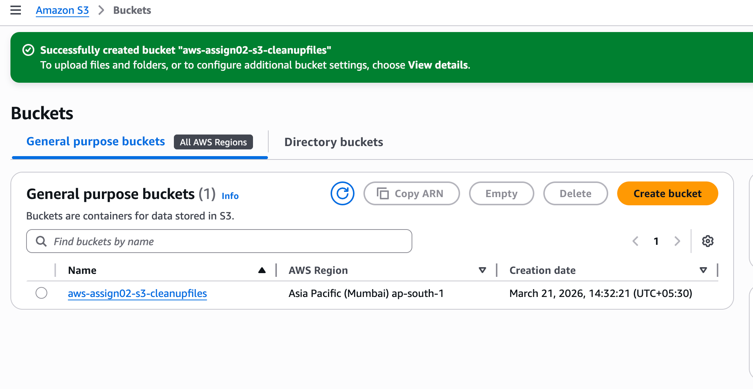
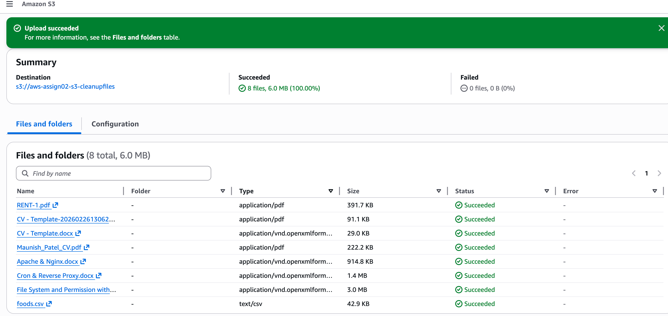

2. Lambda IAM Role:
- In the IAM dashboard, create a new role for Lambda.
- Attach the `AmazonS3FullAccess` policy to this role. (Note: For enhanced security in real-world scenarios, use more restrictive permissions.)

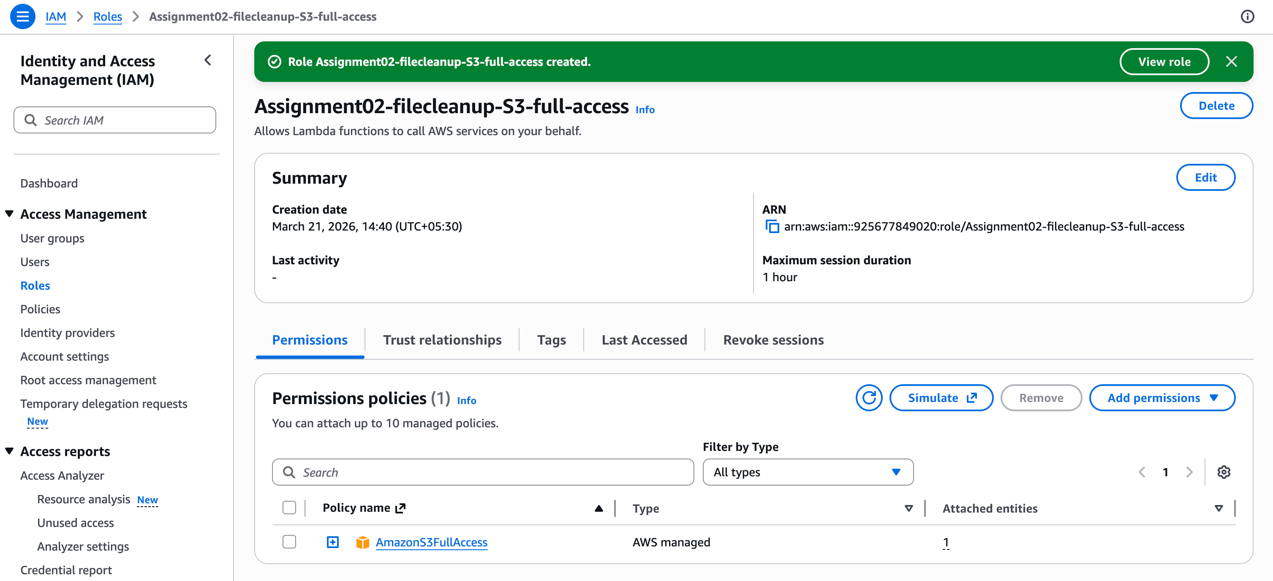

3. Lambda Function:
- Navigate to the Lambda dashboard and create a new function.
- Choose Python 3.x as the runtime.
- Assign the IAM role created in the previous step.
- Write the Boto3 Python script to:
1. Initialize a boto3 S3 client.
2. List objects in the specified bucket.
3. Delete objects older than 30 days.
4. Print the names of deleted objects for logging purposes.

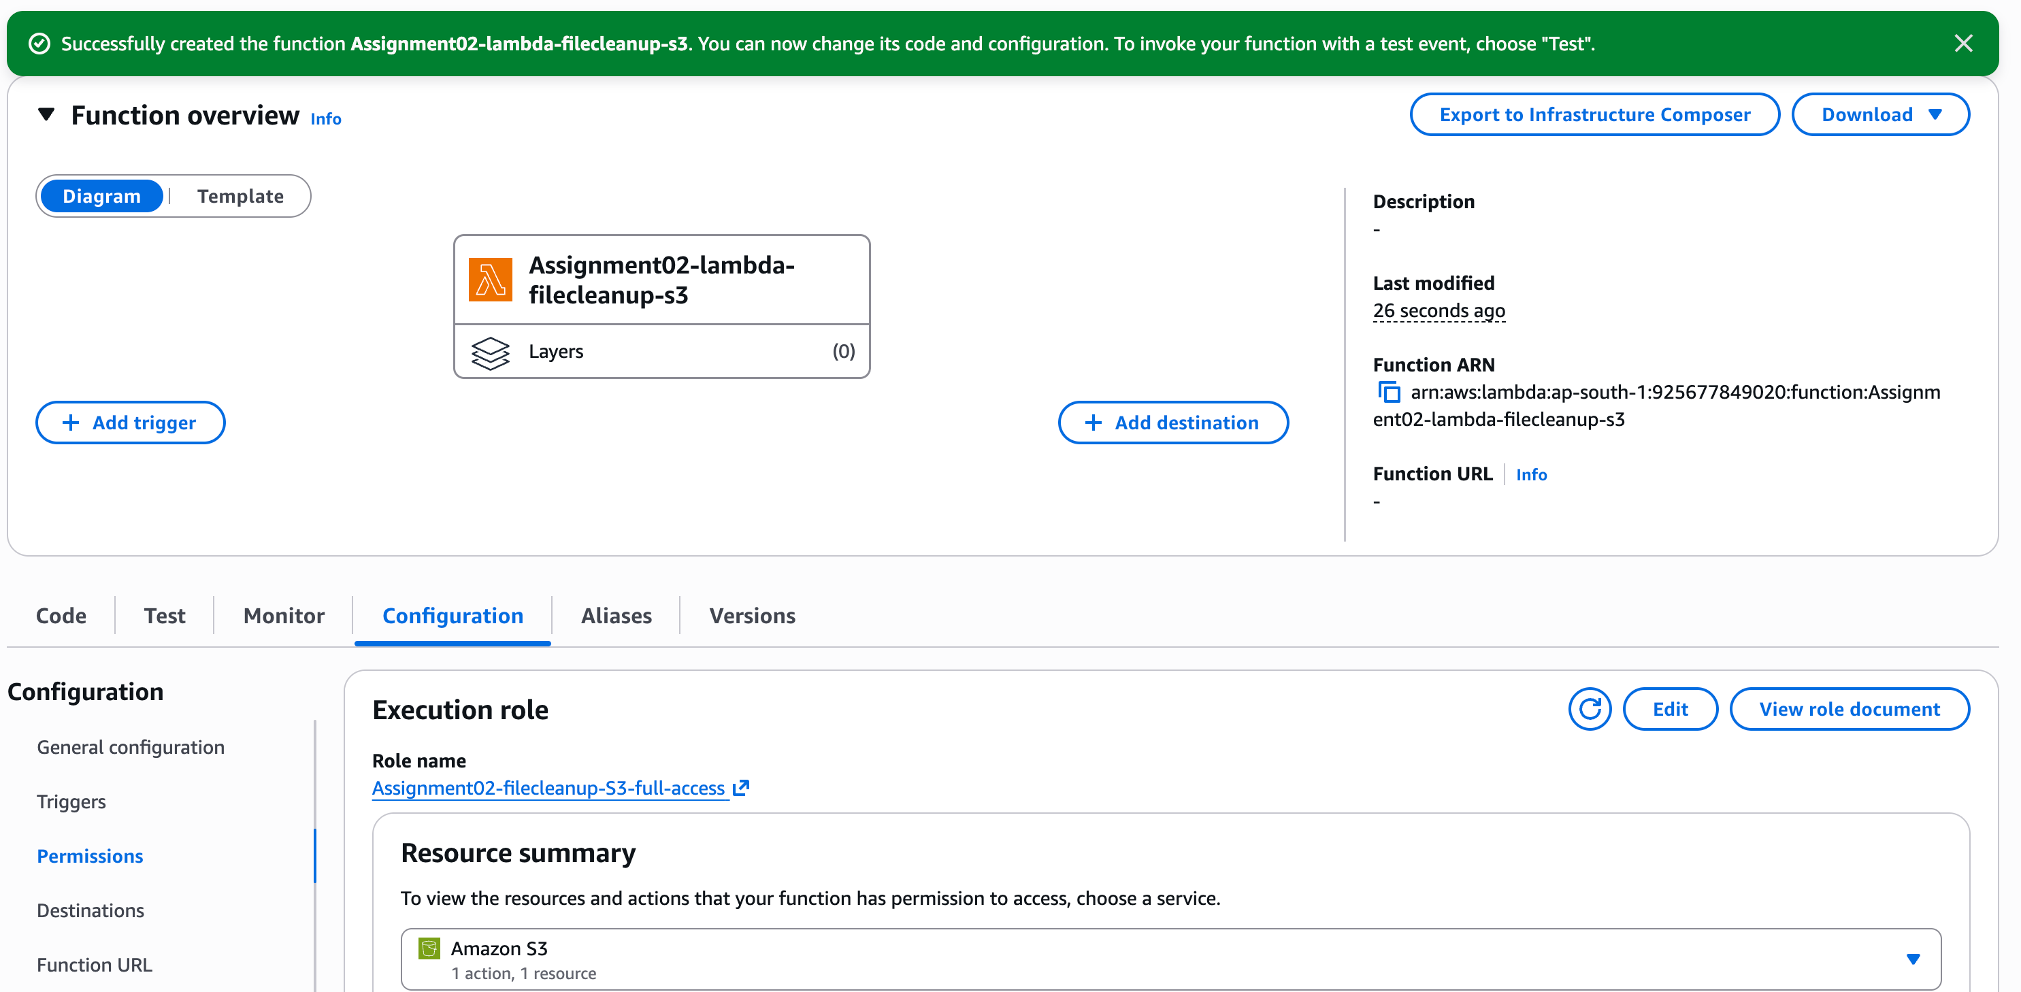

4. Manual Invocation:
- After saving your function, manually trigger it.
- Go to the S3 dashboard and confirm that only files newer than 30 days remain.

Note : I have change the days_old timing from 30 days to 0 days because when we upload the files in s3 bucket it is taking current time and date but for successfully execution of scripts. Please refer the event log in the screenshots.

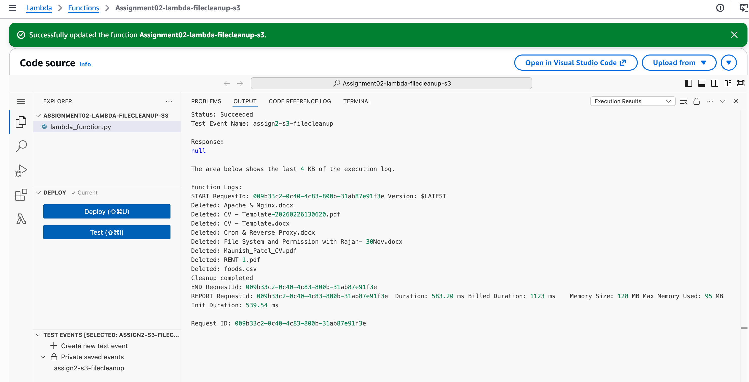

Scripts are as below mentioned :

import boto3
from datetime import datetime, timezone, timedelta

# Initialize S3 client
s3 = boto3.client('s3')

# Bucket name
BUCKET_NAME = "aws-assign02-s3-cleanupfiles"

# Days threshold
DAYS_OLD = 0

def lambda_handler(event, context):

# Calculate cutoff date
cutoff_date = datetime.now(timezone.utc) - timedelta(days=DAYS_OLD)

# List objects in bucket
response = s3.list_objects_v2(Bucket=BUCKET_NAME)

if 'Contents' not in response:
print("Bucket is empty")
return

# Loop through objects
for obj in response['Contents']:
file_name = obj['Key']
last_modified = obj['LastModified']

# Check file age
if last_modified < cutoff_date:

# Delete file
s3.delete_object(
Bucket=BUCKET_NAME,
Key=file_name
)

print(f"Deleted: {file_name}")

print("Cleanup completed")

